The Double Flip-Flop Model of Sleep and Dreams in Relation to EEG Activity

By: Peter Martens and Parker Smith

**Introduction**

Sleep and dreams have been studied both biologically and psychologically for many years now, making a large niche in the literature of consciousness and altered states. Along with this research on where, why, and when sleep occurs within the brain, there have been a multitude of attempts at modeling sleep mathematically, to predict sleep patterns and how disorders/other dysfunctions may result in critical alterations.

One of the more prominent models of the literature is known as the Flip-Flop model (Rempe, Best, & Terman, 2009), where one state flips into another. This model shows the moments when the brain switches from making a beta (wake) brain wave pattern to a delta, and eventually theta wave pattern. The interest of this paper lies in the modeling of the neurons and their peers, creating the waves that are studied with EEG. After observing some of the patterns of frequency between alpha and theta waves, we are interested in what could modulate between the states of NREM, REM, and being awake (Kumar, Rupesh, et al.,2012)(Rempe, Best, & Terman, 2009).

Thus, we are attempting to model firing of neurons when in the alpha, beta, theta, and delta condition using observations of their general wave patterns. As brain waves are the frequency of firings among neurons in the brain, we are using the general hertz range as a base for how they would fire. The higher the wave value, the higher the firing rate. To accomplish this, we first used a model of output from Izkevhich (Izhikevich, 2003) and created it in Matlab, then attempted to recreate it in XPP. In order to achieve the periodic/random nature of the firings, we utilized a cosine function to constantly alter the synaptic input, changing it from excitatory to inhibitory over time.

While the model does not directly simulate the output seen in EEG tests due to the lack of randomness, the model does display periodic increases in firing, and recreates the Hz found for each wave depending on the altered values for two variables: the wave one wants to recreate, and the amount of synaptic voltage. Thus, following along with the Flip-Flop model, it would seem that some mechanism must be at play to indicate that there is a wave change, resulting in a chemical change that alters the voltage of the synaptic firings, as well as the types of charges that are sent. This is most likely done via neurotransmitters, and is explored further in the discussion section.

**Methods**

At first we approached the problem by attempting to pictorially approximate a brain wave, primarily via products and compositions of sin and cos functions. The resulting function ended up being a large product of multiple sine functions, each with a modifier within the sin function on the variable time. In order to approximate this within the confines of a neuron, we utilized a similar set up on a smaller scale, **sin(x)*cos(vx)**  with **v** being the voltage. Then began scaling up by adding in more variables that modified the curvature, resulting in a multiplication of 4 sin functions with modifiers on each theta.However, this approach somewhat ignored the actual biological underpinnings of the process itself.

So, instead, we utilized two separate models of spiking, one by Izhikevich, the other being Syn.ode from Terman, to find a proper alteration for syn.ode to create the spiking pattern that is desired. The Thalamo-Cortical Neuron model in Izhikevich’s paper was the closest that we could get to an accurate simulation, and we utilized it along with his example of a fast spiking neuron to represent the varying firing rates, altered for time and average voltage along said stretch of time. First we simulated what the spiking behavior should be for a neuron starting it’s firing, then we attempted to recreate the firing during delta waves, alpha waves, and theta waves based on the general data provided in Izhikevich, 2003. Figures 1, 2, 3, & 4 show alpha, theta, delta, and beta waves

After recreating the neurons in Matlab, we attempted to recreate the results in XPP by altering syn.ode. However, the spiking was too consistent and would only vary if someone manually altered the synaptic voltage. In order to automate this to a degree, and to provide an example of inhibition inputs, we add in another variable, E, that was multiplied onto the isyn variable. The E variable was dependent on a differential equation composed of cosine, as well as a wave variable that would alter depending on the type of wave that was desired.

**Results**

The model itself works by incorporating aspects of syn.ode, as well as a periodic manipulation of the amount of charge going into the model. This, along with the addition of a variable to determine frequency as well as manipulation of the original parameters, creates an effect that ultimately reflects the expected firing of one pair of neurons firing while one is awake, relaxed, dreaming, or just sleeping.

In order to achieve the proper frequency of firing, we worked with the original syn.ode model, changing sm to 14.5, gl to 2, gna to 37, taun0 to 1, and eps to 0.04. This was done after extensive testing as to how each component would affect the nullclines, and ultimately this configuration provided the most stability and the desired firing rate. Another set of difficulties came with the proper setting of isyn, due to the addition of the periodic switch.

The periodic switch that was added is of the form:

e’ = (cos(t*wave)/400)/300

e = 0

The primary feature of the added variable is the differential equation, as it is what makes the variable move in a periodic way. T stands for time, and “Wave” is another variable, meant to alter the frequency of the cycle between excitation and inhibition. We were unable to find a more fluid way of going between states, which lends us to believe that there is another factor at work which would alter this variable.

The new variable interacts with the primary equation thusly:

v'=-(il(v)+ina(v,.5-n)+ik(v,n))+iapp+2*isyn*e

Where it is directly modulating isyn. It is important to note that there is now a 2 next to isyn, which resulted from changes made to the parameters. Regardless, as time goes on, isyn increases and decreases due to the value of e, which typically moves from -1 to 1. This alters the synaptic input that the neuron is taking in, and thus inhibiting fire or exciting fire, depending on if it is positive or negative.

Another note is that in order to simulate alpha, theta, and delta waves, the wave and isyn parameters must be set to the proper settings. The best settings for the waves (and how figures 5-12 were made) follow:

Alpha (Figures 5,6) wave = 1, isyn = 3

Theta (Figures 7,8) wave = 2, isyn = 6

Delta (Figures 9,10) wave = 4 isyn = 8

Beta (11, 12) wave = 0.75 isyn = 8

The isyn parameter is multiplied by 2 due to increased sensitivity, and the desire to make a more clear firing pattern. The numbers also work well with a pattern that almost develops with the wave to isyn proportion, however when testing the beta and delta waves, their inputs did not follow the 1:3 proportion.

Due to the automated periodic manipulation, e, there is not a singular fixed point, thus while the nullclines are obtainable, a bifurcation diagram is not. However, the nullclines seem to show how the model works, especially with regards to its frequency. As it can be noted from figures 13-16, the nullcline for the alpha wave (Figure 13) has a much higher number of orbits when looking at the nullclines when compared to delta (Figure 14) and theta (Figure 15) waves. Due to the amount of excitation time the periodic manipulation allows for alpha waves before starting an inhibitory cycle, the alpha wave can spike much more frequently, even more so in the beta wave function. If the frequency of e is made higher, then the amount of time the neuron has in an excitatory state before being in rest is lowered, leading to a pattern of lower activation over time.

**Discussion**

We felt that it’s important to look at the overall switch system of sleep/wake and nREM/REM before tackling the system of waves, as the frequency of each neuron set is highly dependent on this mechanism, which in turn makes our system reliant on it. The underlying biology of the system helps in understanding how to model it. As our model would be unable to function without some other mechanism to switch between wave activation, we looked to other possible activators instead. One such model, as mentioned prior, is the Flip Flop Model.

The sleep wake cycle in relation to the flip flop model can be thought of as a series of mutually inhibitory synaptic interactions between the wake promoting and sleep promoting neuronal groups. These neuronal groups can be thought of as functions based on their firing rates competing for influence over the other (in regards to the homeostatic sleep drive) using their neurotransmitter release (Dunmyre, Mashour 2014) .

This homeostatic sleep drive can be thought of as a function of time and increases while awake and decreases during sleep, ultimately determining if we are either awake or asleep. This homeostatic sleep drive however acts on a slower timescale than the faster subsystem of the neuronal groups and their corresponding neurotransmitters. This fast-slow decomposition leads to a hysteresis loop (two loops if you include the nREM/REM system) (Dunmyre, Mashour 2014). These hysteresis loops ultimately determine the trajectory dynamics of the respective systems. Within our model, the occurrence of these loops would dictate the frequency of the wave change, and also the duration of time spent in a specific wave firing pattern.

The wake-promoting neurons are located within the locus coeruleus (LC), dorsal raphe (DR), and the tuberomammillary nucleus (TMN). These wake promoting neuronal groups release the neurotransmitters norepinephrine, serotonin and histamine; which collectively has an inhibitory effect on the sleep promoting neurons. These sleep-promoting neurons are located within the ventrolateral preoptic nucleus (VLPO). Neurons within the VLPO release inhibitory GABA onto the wake-promoting neuronal groups (Dunmyre, Mashour 2014) (Rempe, Best, & Terman, 2009). In our model, these mutual inhibitory influences would be the switch that induces a lower or higher frequency, thus causing the “wave” parameter to shift positions.

Similar dynamics occur when we add a REM-nREM flip flop, transforming the original sleep/wake model into a coupled model. The wake promoting neuronal groups plays a role of inhibiting REM sleep while awake. However once asleep and wake promoting neurons no longer play a role in inhibiting REM sleep, we enter a second loop regarding the regulation of REM and nREM sleep. This nREM-REM transition is governed by a REM-sleep homeostatic drive. This REM sleep drive increases during nREM sleep to promote deactivation of the REM-off neuronal population and the transition to REM sleep. Once in REM sleep, this drive decreases and promotes activation of the REM-off neuronal population, leading to nREM sleep(Dunmyre, Mashour 2014) (Rempe, Best, & Terman, 2009). The implementation of the REM sleep drive is consistent with the concept that nREM-REM cycling is a sleep dependent process, ultimately generating a cycling solution that can be altered based on previously discussed parameters.

With this in mind, you can think of these inhibitory influences competing with each other leading to higher or lower homeostatic sleep values. From this point, those influences change the parameter values of “wave” (and hence e’), and isyn. When inhibition from sleep promoting neurons dominates, the homeostatic sleep drive leads to decreases in EEG activity from beta (awake; wave frequencies of 15 to 20 Hz) to alpha (drowsy; wave frequencies of 8 to 12 Hz). This lowering of frequency (and larger amplitude) is due to the parameter values of “wave” increasing from 0.75 to 1 (this increases e’), and isyn dropping from 8 to 3. Despite these contradictory dynamics, voltage (v’) ultimately increases, leading to a lower frequency within our model (Dunmyre, Mashour 2014) .

Then transitioning from alpha (drowsy; 8 to 12 Hz) to theta (stage 1 sleep; 4 to 7 Hz); during this transition from awake (alpha) to sleep (theta) the parameter value of “wave” goes from 1 to 2, and isyn from 3 to 6; this increase in the wave parameter value also leads to increases in the periodic switch variable e’. Ultimately these increases in parameter values lead to respective increases in the voltage (v’), and hence leading to larger amplitude waves and a lower frequency, as we progress from beta (awake) to alpha (drowsy) to theta (stage-1 nREM sleep) (Kumar, Bhuvanewski 2012).

Upon entering this state of sleep, we transition to the REM-nREM flip flop model, starting at nREM stage 1 sleep, which is associated with theta waves of 4 to 7 Hz. Transitioning from stage 1 and 2 sleep (4 to 7 Hz) to stage 3 and 4 sleep (1 to 4 Hz), where the bodily restorative effects of sleep occur, we observe large amplitude, very slow delta waves of 1 to 4 Hz (Kumar & Bhuvaneswari, 2012). This transition from theta to delta waves with the accompanying larger amplitude is due to a larger voltage (v’) (and hence a lower frequency). This increase in voltage is the result of an increase of the parameter values of isyn from 6 to 8 and “wave” from 2 to 4 (also increasing e’) (Kumar, Bhuvanewski 2012).

During all this nREM sleep, the REM-sleep homeostatic drive continues to increase, until we enter into REM sleep. During REM sleep, EEG frequencies shoot back up to 15 to 20 Hz, therefore leading to lower amplitude, lower voltage waves, very similar to waking beta brain waves. This transition from delta (deep sleep) to beta (REM), involves the parameter values of “wave” decreasing from 4 to 0.75; while isyn stays at 8 during the transition. This leads to a lower voltage, and hence a higher frequency within our model (Kumar, Bhuvanewski 2012). REM sleep promoting neurons also send excitatory stimuli to the wake promoting neurons, therefore impacting the sleep-wake homeostatic drive. This hysteresis loop behavior between nREM-REM sleep continues until we reach a crucial point in relation to the sleep-wake homeostatic drive, causing us to wake up (Dunmyre, Mashour 2014). However it should be noted, possibly due to their similarity of wave voltage and frequencies, that it's a lot more likely to transition from a REM sleep to awake, than from nREM sleep to awake (Peever, Fuller 2017).

**Conclusion**

Our model, while more general and primarily focusing on the firing rates, does do the job rather well. It follows the current research that suggests an exterior occurrence that facilitates a firing rate shift, which we have modeled as an increase in fluctuations between inhibition and excitations. We also posit that there may be a higher intensity of synaptic voltage, which would allow for faster rates in shorter times, or at least consistent rates. However, it is important to note that the e variable we introduced does have a somewhat odd distortion on the spiking of neurons, mainly occurring when there is a higher amount of synaptic charge. It also doesn’t model the minor lulls in Hz, only major lulls, which could possibly be achieved with a more complicated e variable. However, what it does achieve is the proper number of Hz, and happens in accordance with typical firing rates and the brain wave patterns.

For future directions, we would be interested in making a more complicated e variable to properly modulate the firing. We’d also need to fix the curvature problem with high levels of isyn, but we suspect that would be partially solved with changes to the e variable. Otherwise, other parameters may need to be tweaked further to accomplish this goal. But, as a whole, the model achieves the goal it was intended to solve, and simulates firings rather well.

**References**

Andrillon, T., Nir, Y., Cirelli, C., Tononi, G., & Fried, I. (2015). Single-neuron activity and eye movements during human REM sleep and awake vision. Nature Communications, 6(1). doi: 10.1038/ncomms8884

Dunmyre, J. R., Mashour, G. A., & Booth, V. (2014). Coupled Flip-Flop Model for REM Sleep Regulation in the Rat. PLoS ONE, 9(4). doi: 10.1371/journal.pone.0094481

Izhikevich, E. (2003). Simple model of spiking neurons. IEEE Transactions on Neural Networks, 14(6), 1569–1572. doi: 10.1109/tnn.2003.820440

Kumar, J. S., & Bhuvaneswari, P. (2012). Analysis of Electroencephalography (EEG) Signals and Its Categorization–A Study. *Procedia Engineering*, *38*, 2525–2536. doi: 10.1016/j.proeng.2012.06.298

Kumar, Rupesh, et al. “A Mathematical Model towards Understanding the Mechanism of Neuronal Regulation of Wake-NREMS-REMS States.” *PLoS ONE*, vol. 7, no. 8, 2012, doi:10.1371/journal.pone.0042059.

Peever, J., & Fuller, P. M. (2017). The Biology of REM Sleep. *Current Biology*, *27*(22). doi: 10.1016/j.cub.2017.10.026

Rempe, M. J., Best, J., & Terman, D. (2009). A mathematical model of the sleep/wake cycle. Mathematical Biology. doi: DOI 10.1007/s00285-009-0276-5

Siclari, F., Baird, B., Perogamvros, L., Bernardi, G., Larocque, J. J., Riedner, B., … Tononi, G. (2017). The neural correlates of dreaming. Nature Neuroscience, 20(6), 872–878. doi: 10.1038/nn.4545

**Appendix**

**Figure 1**

Starting firing rate of an Alpha wave

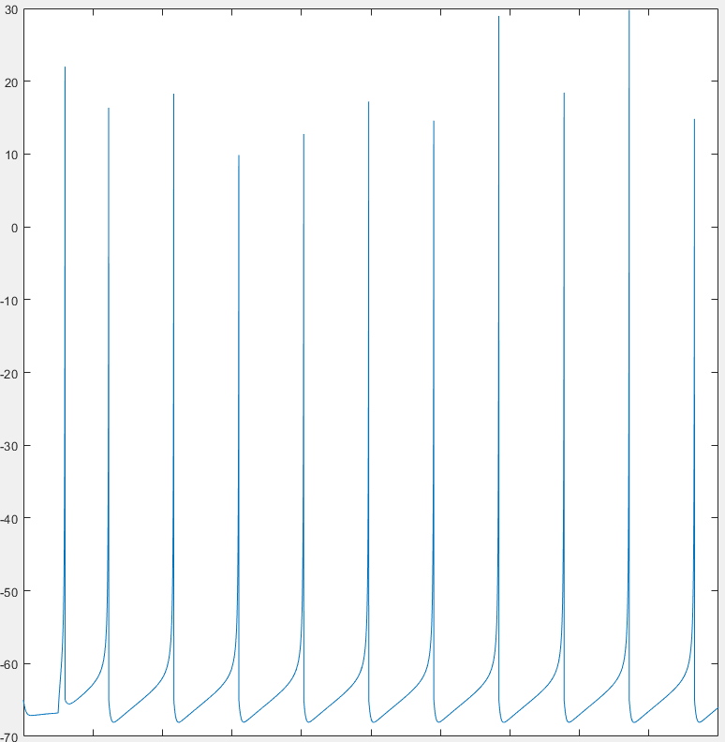

**Figure 2**

Starting firing rate of a Theta wave

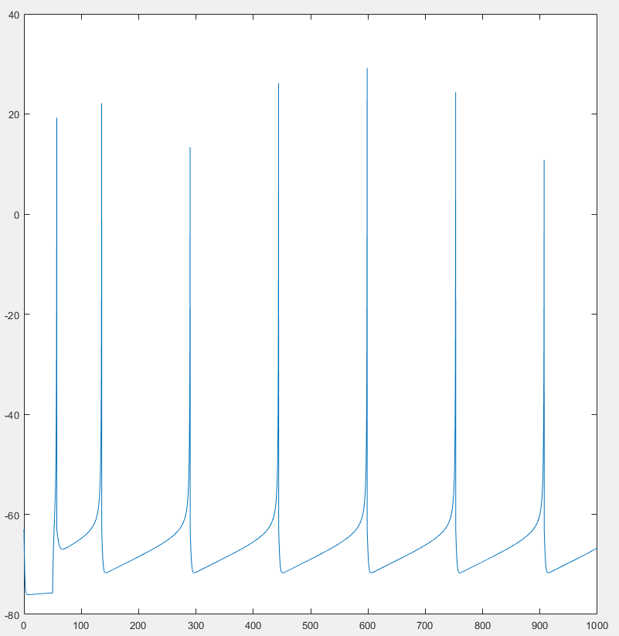

**Figure 3**

Starting firing rate of a Delta wave

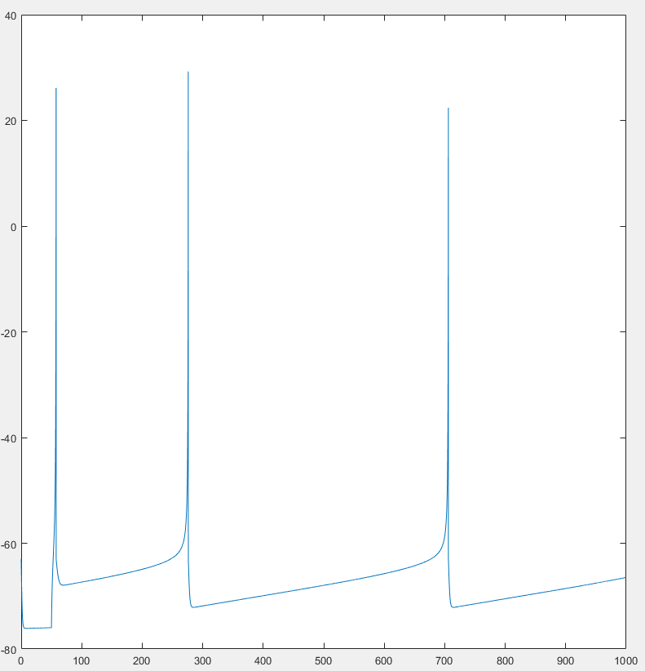

**Figure 4**

Starting firing rate of a Beta wave

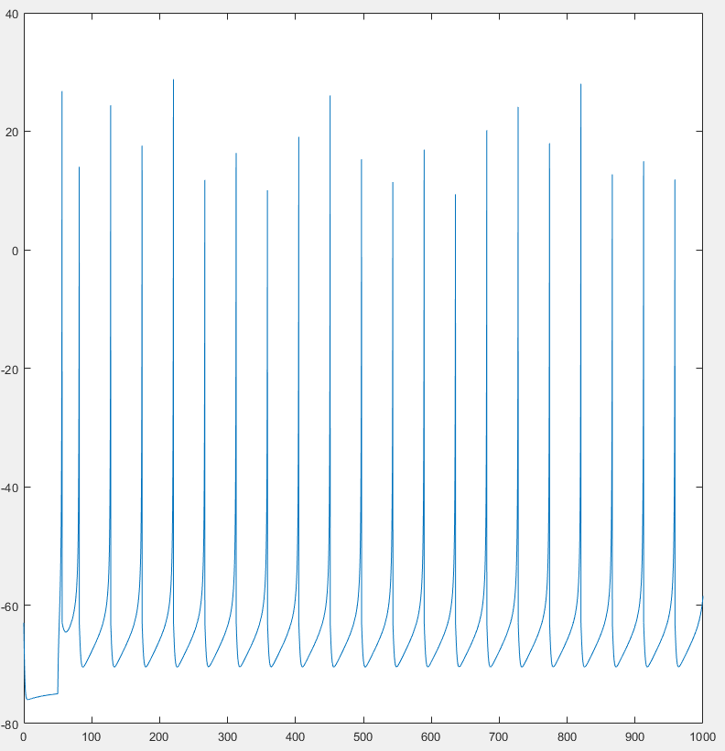

**Figure 5**

XPP modeled firing pattern for an Alpha Wave, shown at 10000 ms. Inhibition wave starts a little after 1200 ms, then again around 3600 and so on.

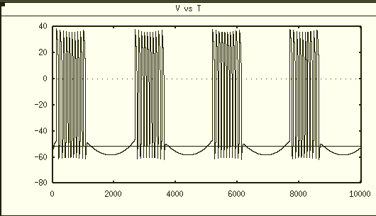

**Figure 6**

Alpha wave pattern exhibited at a scale of 1000 ms

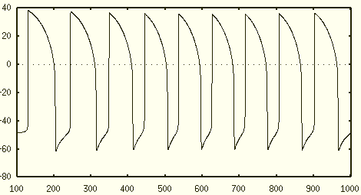

**Figure 7**

Theta wave pattern with inhibition wave that hits around 550 until around 1100, cycles.

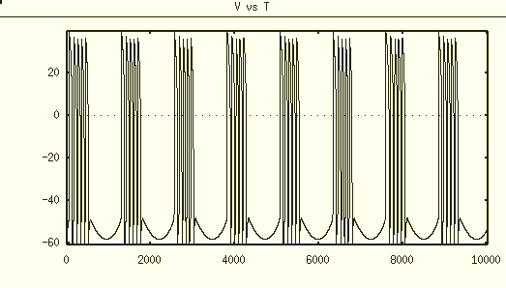

**Figure 8**

Theta wave pattern exhibited at a scale of 1000 ms

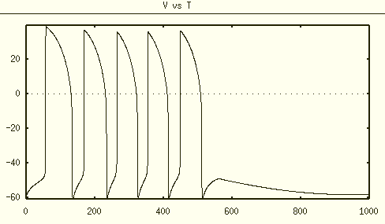

**Figure 9**

Delta wave pattern with inhibition wave that hits around 300 until around 600, then cycles.

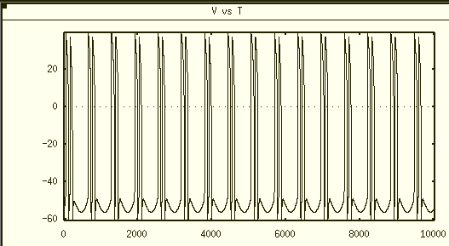

**Figure 10**

Delta wave pattern exhibited at a scale of 1000 ms

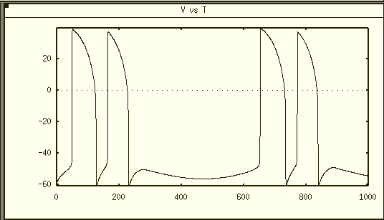

**Figure 11**

Belta wave pattern with inhibition wave that hits around 1900 until around 3800, then cycles.

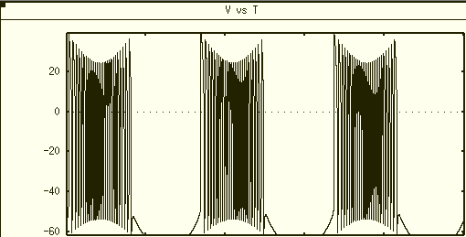

**Figure 12**

Beta wave pattern exhibited at a scale of 1000 ms

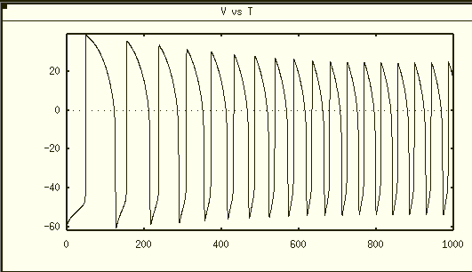

**Figure 13**

Nullcline and integration for alpha waves. Notably more activity due to a longer time spent in an excitatory state due to the frequency of firing shifting with the modulation of periodic variable e.Whenever the model attempts to settle due to the inhibitory wave, it is pushed back into an excitatory state as the nullcline shifts with the increase of isyn. Then, as e decreases, isyn eventually becomes negative or 0, inducing an inhibitory state.

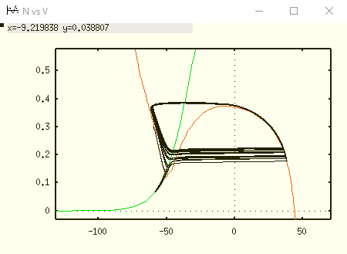

**Figure 14**

Nullcline and integration for theta waves. Less activity than alpha due to a shorter time spent in an excitatory state due to the frequency of firing shifting with the modulation of periodic variable e. Whenever the model attempts to settle due to the inhibitory wave, it is pushed back into an excitatory state as the nullcline shifts with the increase of isyn. Then, as e decreases, isyn eventually becomes negative or 0, inducing an inhibitory state.

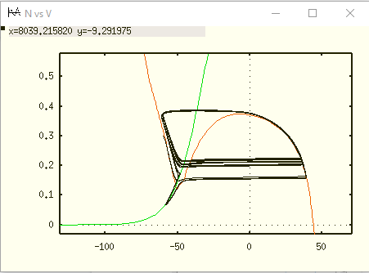

**Figure 15**

Nullcline and integration for delta waves. Lowest activity due to having the shortest time spent in an excitatory state due to the frequency of firing shifting with the modulation of periodic variable e. Whenever the model attempts to settle due to the inhibitory wave, it is pushed back into an excitatory state as the nullcline shifts with the increase of isyn. Then, as e decreases, isyn eventually becomes negative or 0, inducing an inhibitory state.

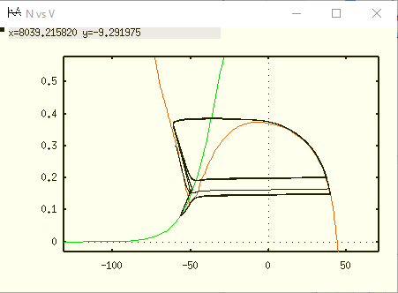

**Figure 16**

Nullcline and integration for beta waves. highest activity due to having the longest time spent in an excitatory state due to the frequency of firing shifting with the modulation of periodic variable e. Whenever the model attempts to settle due to the inhibitory wave, it is pushed back into an excitatory state as the nullcline shifts with the increase of isyn. Then, as e decreases, isyn eventually becomes negative or 0, inducing an inhibitory state.

